Banana Problem
Name: Kurumeti Mitesh
SRN: PES2UG24AM080
SECTION: 3rd sem AIML-B
Title: GitHub Trending Repositories
Subject:- UE24MA242A - Mathematics for Computer Science Engineers

Python code:
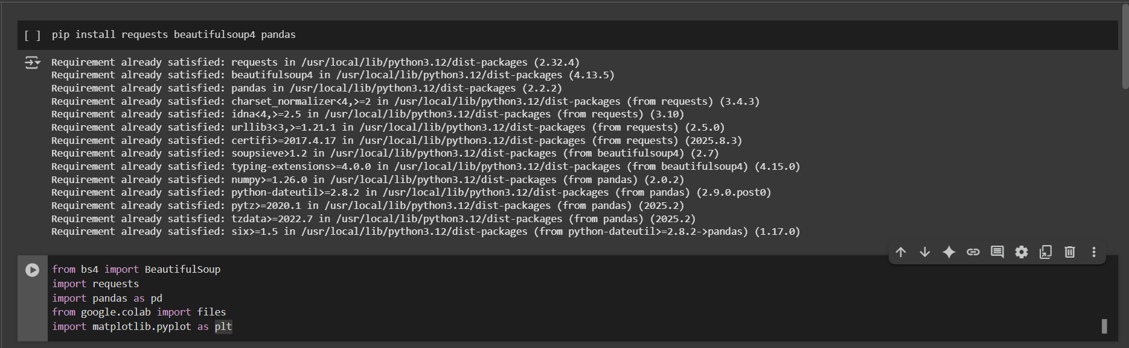
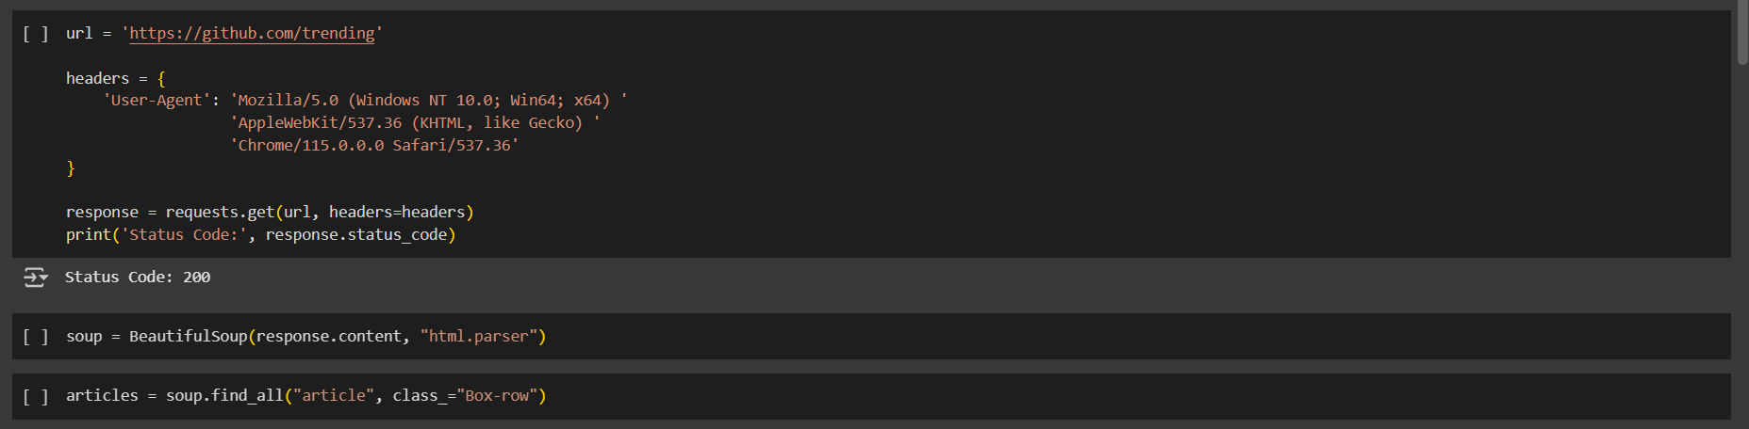
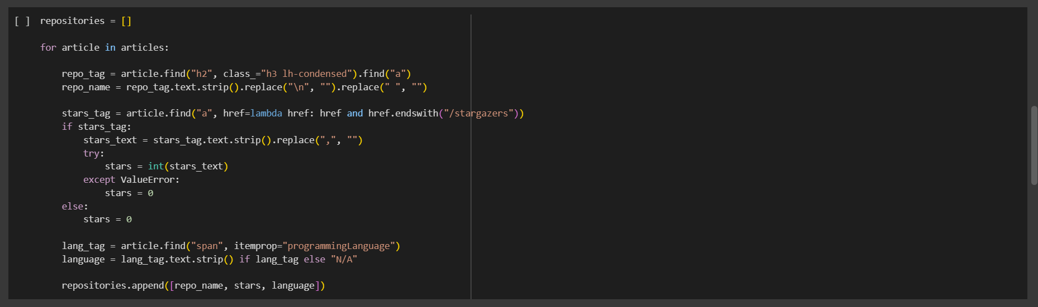
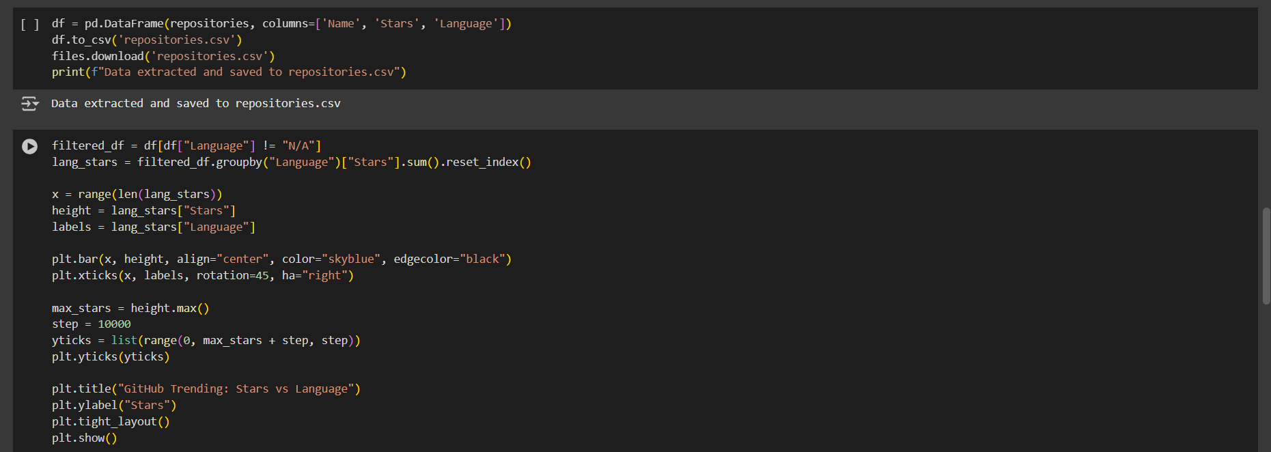

Descriptive statistics results:
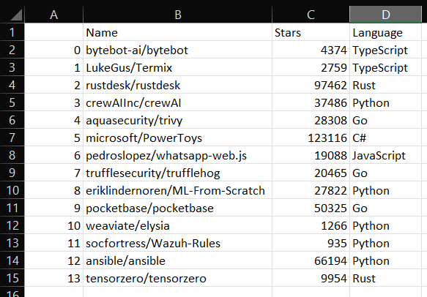

Visualization results:
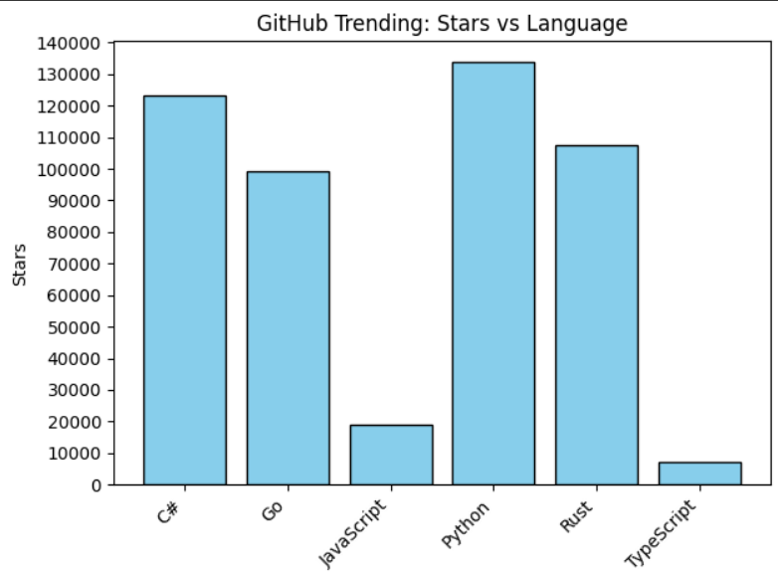
Inferences drawn from the descriptive statistics and visualizations:
- Among the trending repositories, Python stands out with the highest total stars, showing it’s currently attracting a lot of attention.
- TypeScript has the fewest stars, suggesting that projects in TypeScript are
less at this moment.

